Inception module V3

0. Environment

|  |  |
| --- | --- |
| DataSet | CIFAR-10 |
| Language | Python3.5 & Tensorflow 1.0 |
| optimizer | Adam |
| Loss function | Cross entropy Loss |

Input : 32x32x3 size image

1. initialize

|  |  |
| --- | --- |
| layer | max_pool(stride = 2, pool_size = 2, pad) |
| output | 16x16x3 |
| layer | 1x1 conv (filter = 64) |
| output | 16x16x64 |

2. module (10 times)

|  |  |  |  |  |
| --- | --- | --- | --- | --- |
| layer | 1x1 conv  (fileter = 16) | 1x1 conv  (fileter = 16) | 1x1 conv  (fileter = 16) | max_pool  (size = 3x3, pad) |
| 3x3 conv  (filter = 16, pad) | 3x3 conv  (filter = 16, pad) | 1x1 conv  (filter = 16, pad) |
| 3x3 conv  (filter = 16, pad) |
| output | 16x16x16 | 16x16x16 | 16x16x16 | 16x16x16 |
| concatenate | 16x16x64 | | | |
| Layer | relu | | | |
| output | 16x16x64 | | | |

3.Fully connected

|  |  |
| --- | --- |
| layer | Affine (W = 16x16x64,1024) |
| output | 1024 |
| layer | Affine (W = 1024, 10) |
| output | 10 |

4. Overall

|  |  |
| --- | --- |
| Training(7600 iteration) | Time : 4985.301273584366 seconds |
| Accuracy : 0.626 |
| Validation | Accuracy : 0.595 |
| Re-training(64 iteration) | Accuracy : 0.635 |
| Re-Validation | Accuracy : 0.595 |
| Test | Acurracy : 0.589 |

Training

Iteration 0: with minibatch training loss = 37.8 and accuracy of 0.12

Iteration 100: with minibatch training loss = 2.2 and accuracy of 0.17

Iteration 200: with minibatch training loss = 1.81 and accuracy of 0.33

Iteration 300: with minibatch training loss = 1.69 and accuracy of 0.38

Iteration 400: with minibatch training loss = 1.76 and accuracy of 0.31

Iteration 500: with minibatch training loss = 1.71 and accuracy of 0.39

Iteration 600: with minibatch training loss = 1.37 and accuracy of 0.47

Iteration 700: with minibatch training loss = 1.56 and accuracy of 0.45

Epoch 1, Overall loss = 4.02 and accuracy of 0.352

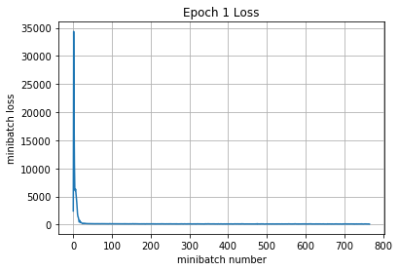

Iteration 800: with minibatch training loss = 1.62 and accuracy of 0.39

Iteration 900: with minibatch training loss = 1.49 and accuracy of 0.47

Iteration 1000: with minibatch training loss = 1.54 and accuracy of 0.45

Iteration 1100: with minibatch training loss = 1.57 and accuracy of 0.47

Iteration 1200: with minibatch training loss = 1.53 and accuracy of 0.56

Iteration 1300: with minibatch training loss = 1.33 and accuracy of 0.52

Iteration 1400: with minibatch training loss = 1.49 and accuracy of 0.5

Iteration 1500: with minibatch training loss = 1.15 and accuracy of 0.58

Epoch 2, Overall loss = 1.5 and accuracy of 0.457

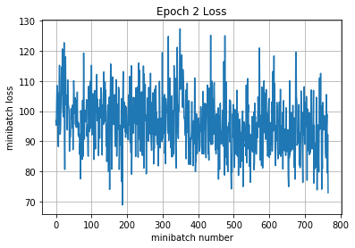

Iteration 1600: with minibatch training loss = 1.28 and accuracy of 0.47

Iteration 1700: with minibatch training loss = 1.32 and accuracy of 0.56

Iteration 1800: with minibatch training loss = 1.32 and accuracy of 0.42

Iteration 1900: with minibatch training loss = 1.5 and accuracy of 0.45

Iteration 2000: with minibatch training loss = 1.43 and accuracy of 0.47

Iteration 2100: with minibatch training loss = 1.59 and accuracy of 0.44

Iteration 2200: with minibatch training loss = 1.51 and accuracy of 0.47

Epoch 3, Overall loss = 1.39 and accuracy of 0.497

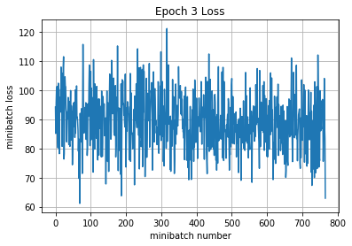

Iteration 2300: with minibatch training loss = 1.5 and accuracy of 0.42

Iteration 2400: with minibatch training loss = 1.46 and accuracy of 0.44

Iteration 2500: with minibatch training loss = 1.3 and accuracy of 0.56

Iteration 2600: with minibatch training loss = 1.31 and accuracy of 0.48

Iteration 2700: with minibatch training loss = 1.29 and accuracy of 0.58

Iteration 2800: with minibatch training loss = 1.23 and accuracy of 0.55

Iteration 2900: with minibatch training loss = 1.1 and accuracy of 0.66

Iteration 3000: with minibatch training loss = 1.29 and accuracy of 0.5

Epoch 4, Overall loss = 1.33 and accuracy of 0.523

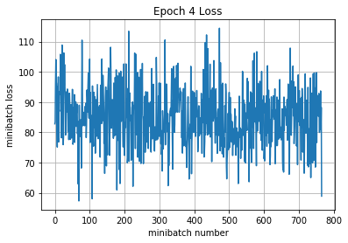

Iteration 3100: with minibatch training loss = 1.33 and accuracy of 0.52

Iteration 3200: with minibatch training loss = 1.31 and accuracy of 0.53

Iteration 3300: with minibatch training loss = 1.42 and accuracy of 0.52

Iteration 3400: with minibatch training loss = 1.34 and accuracy of 0.52

Iteration 3500: with minibatch training loss = 1.33 and accuracy of 0.55

Iteration 3600: with minibatch training loss = 1.29 and accuracy of 0.59

Iteration 3700: with minibatch training loss = 1.32 and accuracy of 0.56

Iteration 3800: with minibatch training loss = 1.31 and accuracy of 0.48

Epoch 5, Overall loss = 1.27 and accuracy of 0.545

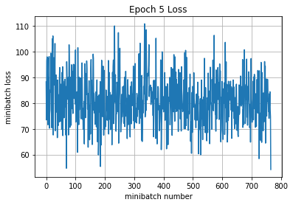

Iteration 3900: with minibatch training loss = 1.26 and accuracy of 0.55

Iteration 4000: with minibatch training loss = 1.27 and accuracy of 0.53

Iteration 4100: with minibatch training loss = 1.13 and accuracy of 0.59

Iteration 4200: with minibatch training loss = 1.21 and accuracy of 0.53

Iteration 4300: with minibatch training loss = 1.1 and accuracy of 0.69

Iteration 4400: with minibatch training loss = 1.16 and accuracy of 0.58

Iteration 4500: with minibatch training loss = 1.06 and accuracy of 0.53

Epoch 6, Overall loss = 1.23 and accuracy of 0.561

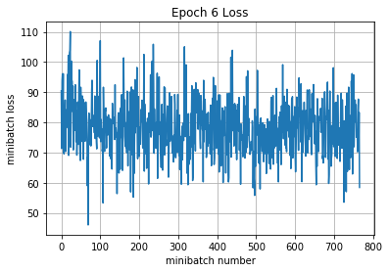

Iteration 4600: with minibatch training loss = 1.27 and accuracy of 0.56

Iteration 4700: with minibatch training loss = 1.25 and accuracy of 0.55

Iteration 4800: with minibatch training loss = 1.38 and accuracy of 0.5

Iteration 4900: with minibatch training loss = 1.08 and accuracy of 0.59

Iteration 5000: with minibatch training loss = 1.21 and accuracy of 0.59

Iteration 5100: with minibatch training loss = 1.14 and accuracy of 0.66

Iteration 5200: with minibatch training loss = 1.3 and accuracy of 0.58

Iteration 5300: with minibatch training loss = 1.25 and accuracy of 0.58

Epoch 7, Overall loss = 1.18 and accuracy of 0.579

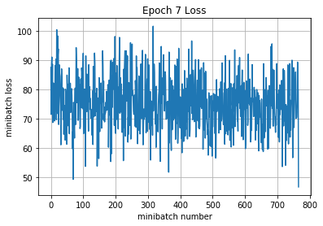

Iteration 5400: with minibatch training loss = 0.979 and accuracy of 0.66

Iteration 5500: with minibatch training loss = 1.2 and accuracy of 0.59

Iteration 5600: with minibatch training loss = 0.89 and accuracy of 0.72

Iteration 5700: with minibatch training loss = 0.909 and accuracy of 0.7

Iteration 5800: with minibatch training loss = 1.14 and accuracy of 0.62

Iteration 5900: with minibatch training loss = 1.29 and accuracy of 0.56

Iteration 6000: with minibatch training loss = 1.07 and accuracy of 0.61

Iteration 6100: with minibatch training loss = 1.26 and accuracy of 0.59

Epoch 8, Overall loss = 1.14 and accuracy of 0.595

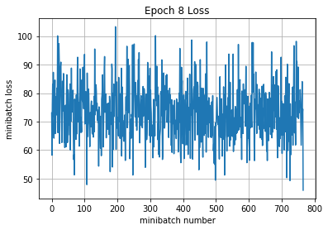

Iteration 6200: with minibatch training loss = 1.08 and accuracy of 0.59

Iteration 6300: with minibatch training loss = 1.02 and accuracy of 0.66

Iteration 6400: with minibatch training loss = 1.18 and accuracy of 0.53

Iteration 6500: with minibatch training loss = 0.949 and accuracy of 0.58

Iteration 6600: with minibatch training loss = 1.16 and accuracy of 0.59

Iteration 6700: with minibatch training loss = 1.23 and accuracy of 0.55

Iteration 6800: with minibatch training loss = 0.954 and accuracy of 0.66

Epoch 9, Overall loss = 1.1 and accuracy of 0.608

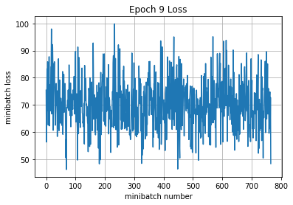

Iteration 6900: with minibatch training loss = 0.995 and accuracy of 0.66

Iteration 7000: with minibatch training loss = 0.929 and accuracy of 0.66

Iteration 7100: with minibatch training loss = 1.09 and accuracy of 0.58

Iteration 7200: with minibatch training loss = 0.849 and accuracy of 0.7

Iteration 7300: with minibatch training loss = 1.18 and accuracy of 0.56

Iteration 7400: with minibatch training loss = 0.953 and accuracy of 0.59

Iteration 7500: with minibatch training loss = 1.06 and accuracy of 0.66

Iteration 7600: with minibatch training loss = 0.983 and accuracy of 0.62

Epoch 10, Overall loss = 1.05 and accuracy of 0.626

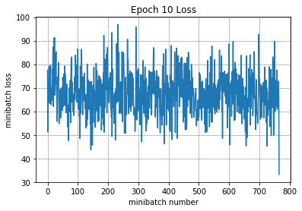

4985.301273584366

Validation

Epoch 1, Overall loss = 1.1 and accuracy of 0.595

Training

Epoch 1, Overall loss = 1.01 and accuracy of 0.635

Validation

Epoch 1, Overall loss = 1.1 and accuracy of 0.595

Test

Epoch 1, Overall loss = 1.14 and accuracy of 0.589

[85]:

(1.1386481319427491, 0.58909999999999996)